Python Project

## Topic: Polls Management System

SE IT-A

Trupti Bhuta 12

Rhea D’souza 32

Rachel Mascarenhas 64

Voleta Noronha 67

**Aim:** Python Program to create a GUI using tkinter for Polls Management System.

**Theory:** Python offers multiple options for developing GUI (Graphical User Interface). Out of all the GUI methods, tkinter is most commonly used method. It is a standard Python interface to the Tk GUI toolkit shipped with Python. Python with tkinter outputs the fastest and easiest way to create the GUI applications. Creating a GUI using tkinter is an easy task.

Polls Management System was implemented for college level. Voter information, Candidate information is to be taken as input and saved in database. The votes are to be counted. A voter enters his/her vote and through button is sent to the database created. Similarly, a candidate enters his/her information and it is sent to database.

SQLite3 can be integrated with Python using sqlite3 module, which was written by Gerhard Haring. It provides an SQL interface. The Voter table consists of all the attributes present on the GUI form. In the same way, Candidate table also consists of the attributes present on the form. Every entry of either Candidate or Voter will be unique because of the unique attribute PID.

Use of multiple windows in python makes the GUI dynamic and more interactive. Adding buttons, labels, entry widgets, option menus, etc. makes the form lively. Python can be used to build much more interactive forms using GUI tkinter. Every button can be associated with a command attribute that tells it a function to be performed.

Classes make python easier to use. Classes lead to object oriented programming which is more used and easier to understand. OOP makes creating forms and a GUI window much faster and coding is easy. Constructors for each class are to be created to pass arguments.

**Program code:**

from tkinter import *

import sqlite3

def Vote():

root1=Tk()

root1.title("Voters Application")

p1=Page1(root1)

root1.mainloop()

def Candidate():

root2=Tk()

root2.title("Candidate Application")

p2=Page2(root2)

root2.mainloop()

class Main:

def __init__(self,root):

self.f1=Frame(root,height=600, width=600)

self.f1.propagate(0)

self.f1.pack()

self.f1.configure(background='light blue')

'''self.c=Canvas(self.f1,height=300,width=300,bg="red")

self.file1=PhotoImage(file="abc.png")

self.i1=self.c.create_image(100,40,anchor=N,image=self.file1)'''

self.label1=Label(self.f1,text="WELCOME TO",font=('Elephant',50,'bold'),fg='RED',bg='light blue').place(x=10,y=20)

self.label2=Label(self.f1,text="ELECTION 2018",font=('Arial Black',50,'bold'),fg='RED',bg='yellow').place(x=8,y=150)

self.label3=Label(self.f1,text="Are you Voter?",font=('Harlow Solid Italics',20,'bold italic'),fg='Red',bg='light blue').place(x=100,y=300)

self.label4=Label(self.f1,text="Click here:",font=('Arial Black',18,'bold'),fg='black',bg='light blue').place(x=100,y=350)

self.button1=Button(self.f1,text="Voter",width=15,bd=5,fg='blue4',font=('Arial Black',18,'bold'),command=Vote,activeforeground='black')

self.button1.place(x=300,y=350)

self.label3=Label(self.f1,text="Want to register for Election?",font=('Harlow Solid Italics',20,'bold italic'),fg='Red',bg='light blue').place(x=100,y=450)

self.label3=Label(self.f1,text="Click here:",font=('Arial Black',18,'bold'),fg='black',bg='light blue').place(x=100,y=500)

self.button2=Button(self.f1,text="Candidate",width=15,bd=5,font=('Arial Black',18,'bold'),fg='blue4',activeforeground='black',command=Candidate)

self.button2.place(x=300,y=500)

class Page1:

def __init__(self,root1):

self.root1=root1

self.f=Frame(self.root1,height=2000,width=2000)

self.f.propagate(0)

self.f.pack()

self.f.configure(background='light blue')

'''self.c=Canvas(self.f,height=300,width=300,bg="red")

self.file1=PhotoImage(file="abc.png")

self.i1=self.c.create_image(100,40,anchor=N,image=self.file1)'''

self.ev1=StringVar()

self.ev2=StringVar()

self.ev3=StringVar()

self.l=Label(self.f,text="Voters Information",font=('Elephant',30,'bold'),fg='Red',bg='light blue').place(x=600,y=10)

self.l1=Label(self.f,text="Enter PID",font=('Arial Black',14,'bold'),bg='light blue').place(x=100,y=100)

self.l2=Label(self.f,text="Enter Name",font=('Arial Black',14,'bold'),bg='light blue').place(x=100,y=200)

self.l3=Label(self.f,text="Enter Age",font=('Arial Black',14,'bold'),bg='light blue').place(x=100,y=300)

self.l4=Label(self.f,text="Enter Gender",font=('Arial Black',14,'bold'),bg='light blue').place(x=100,y=400)

self.l5=Label(self.f,text="Enter Candidate",font=('Arial Black',14,'bold'),bg='light blue').place(x=100,y=500)

self.e1=Entry(self.f,width=28,font=('Arial',12),textvariable=self.ev1)

self.e1.place(x=300,y=100)

self.e2=Entry(self.f,width=28,font=('Arial',12),textvariable=self.ev2)

self.e2.place(x=300,y=200)

self.e3=Entry(self.f,width=28,font=('Arial',12),textvariable=self.ev3)

self.e3.place(x=300,y=300)

self.vvar1=StringVar()

self.vvar1.set("SELECT")

self.s=OptionMenu(self.f,self.vvar1,"Male","Female")

self.s.place(x=300,y=400)

self.var=StringVar()

self.var.set("SELECT")

self.s1=OptionMenu(self.f,self.var,"Trupti","Rachel","Rhea","Voleta")

self.s1.place(x=300,y=500)

self.b1=Button(self.f,text="Check",width=15,bd=5,command=self.display)

self.b1.place(x=100,y=600)

self.b2=Button(self.f,text="Reset",width=15,bd=5,command=self.reset)

self.b2.place(x=275,y=600)

self.b3=Button(self.f,text="Submit",width=15,bd=5,command=self.insert)

self.b3.place(x=440,y=600)

def display(self):

str1=self.e1.get()

str2=self.e2.get()

str3=self.e3.get()

str4=self.vvar1.get()

str5=self.var.get()

l6=Label(self.f,text="Details entered are",font=('Arial Black',18,'bold'),fg='red',bg='light blue').place(x=1000,y=100)

l7=Label(self.f,text="Your PID is: "+str(str1),font=('Verdana',15,'bold'),bg='light blue').place(x=800,y=200)

l8=Label(self.f,text="Your name is: "+str(str2),font=('Verdana',15,'bold'),bg='light blue').place(x=800,y=300)

l9=Label(self.f,text="Your age is: "+str(str3),font=('Verdana',15,'bold'),bg='light blue').place(x=800,y=400)

l10=Label(self.f,text="Your Gender is: "+str(str4),font=('Verdana',15,'bold'),bg='light blue').place(x=800,y=500)

l11=Label(self.f,text="Candidate chosen: "+str(str5),font=('Verdana',15,'bold'),bg='light blue').place(x=800,y=600)

def insert(self):

self.conn=sqlite3.connect("Election.db")

self.cur=self.conn.cursor()

self.cur.execute("create table if not exists Voter(PID varchar(20) unique, Name varchar(20) , Age varchar(20),Gender varchar(20),Candidate varchar(20))")

print(self.cur.fetchall())

str1=self.e1.get()

str2=self.e2.get()

str3=self.e3.get()

str4=self.vvar1.get()

str5=self.var.get()

sql1="insert into Voter values('%s','%s','%s','%s','%s')"%(str1,str2,str3,str4,str5)

self.cur.execute(sql1)

print(self.cur.fetchall())

self.cur.execute("select * from Voter")

print(self.cur.fetchall())

def reset(self):

self.e1.delete(0,END)

self.e2.delete(0,END)

self.e3.delete(0,END)

self.vvar1.set(" ")

self.var.set(" ")

class Page2:

def __init__(self,root2):

self.root2=root2

self.f=Frame(self.root2,height=2000,width=2000)

self.f.propagate(0)

self.f.pack()

self.f.configure(background='pink')

#c=Canvas(f,height=2000,width=2000,bg='light blue')

#c.pack()

'''file1=PhotoImage(file="abc.png")

i1=c.create_image(10,2000, anchor=N,image=file1)'''

self.ev1=StringVar()

self.ev2=StringVar()

self.ev3=StringVar()

self.l=Label(self.f,text="Candidates Information",font=('Elephant',30,'bold'),fg='Red',bg='light blue')

self.l.place(x=500,y=10)

self.l1=Label(self.f,text="Enter PID",font=('Arial Black',14,'bold'),bg='light blue')

self.l1.place(x=100,y=100)

self.l2=Label(self.f,text="Enter Name",font=('Arial Black',14,'bold'),bg='light blue')

self.l2.place(x=100,y=200)

self.l3=Label(self.f,text="Enter Age",font=('Arial Black',14,'bold'),bg='light blue')

self.l3.place(x=100,y=300)

self.l4=Label(self.f,text="Enter Gender",font=('Arial Black',14,'bold'),bg='light blue')

self.l4.place(x=100,y=400)

self.l5=Label(self.f,text="Enter Year",font=('Arial Black',14,'bold'),bg='light blue')

self.l5.place(x=100,y=500)

self.e1=Entry(self.f,width=28,font=('Arial',12))

self.e1.place(x=300,y=100)

self.e2=Entry(self.f,width=28,font=('Arial',12))

self.e2.place(x=300,y=200)

self.e3=Entry(self.f,width=28,font=('Arial',12))

self.e3.place(x=300,y=300)

self.vvar1=StringVar()

self.vvar1.set("SELECT")

self.s=OptionMenu(self.f,self.vvar1,"Male","Female")

self.s.place(x=300,y=400)

self.var=StringVar()

self.var.set(" ")

self.s1=OptionMenu(self.f,self.var,"SE","TE","BE").place(x=300,y=500)

self.b1=Button(self.f,text="Check",width=15,bd=5,command=self.display).place(x=100,y=600)

self.b2=Button(self.f,text="Reset",width=15,bd=5,command=self.reset).place(x=275,y=600)

self.b3=Button(self.f,text="Submit",width=15,bd=5,command=self.insert).place(x=440,y=600)

def display(self):

str1=self.e1.get()

str2=self.e2.get()

str3=self.e3.get()

str4=self.vvar1.get()

str5=self.var.get()

l6=Label(self.f,text="Details entered are",font=('Arial Black',18,'bold'),fg='red',bg='light blue').place(x=1000,y=100)

l7=Label(self.f,text="Your PID is: "+str(str1),font=('Verdana',15,'bold'),bg='light blue').place(x=800,y=200)

l8=Label(self.f,text="Your name is: "+str(str2),font=('Verdana',15,'bold'),bg='light blue').place(x=800,y=300)

l9=Label(self.f,text="Your age is: "+str(str3),font=('Verdana',15,'bold'),bg='light blue').place(x=800,y=400)

l10=Label(self.f,text="Your Gender is: "+str(str4),font=('Verdana',15,'bold'),bg='light blue').place(x=800,y=500)

l11=Label(self.f,text="Year: "+str(str5),font=('Verdana',15,'bold'),bg='light blue').place(x=800,y=600)

def insert(self):

self.conn=sqlite3.connect("Election.db")

self.cur=self.conn.cursor()

self.cur.execute("create table if not exists Candidate(PID varchar(20) unique, Name varchar(20) , Age varchar(20),Gender varchar(20),Year varchar(20))")

print(self.cur.fetchall())

str1=self.e1.get()

str2=self.e2.get()

str3=self.e3.get()

str4=self.vvar1.get()

str5=self.var.get()

sql1="insert into Voter values('%s','%s','%s','%s','%s')"%(str1,str2,str3,str4,str5)

self.cur.execute(sql1)

print(self.cur.fetchall())

self.cur.execute("select * from Voter")

print(self.cur.fetchall())

def reset(self):

self.e1.delete(0,END)

self.e2.delete(0,END)

self.e3.delete(0,END)

self.vvar1.set(" ")

self.var.set(" ")

root=Tk()#create root window

root.title("ELECTIONS 2018")

main=Main(root)#creating an object to class

root.mainloop()#root window handles the mouse events

**Outputs:**

First window



Voter window:

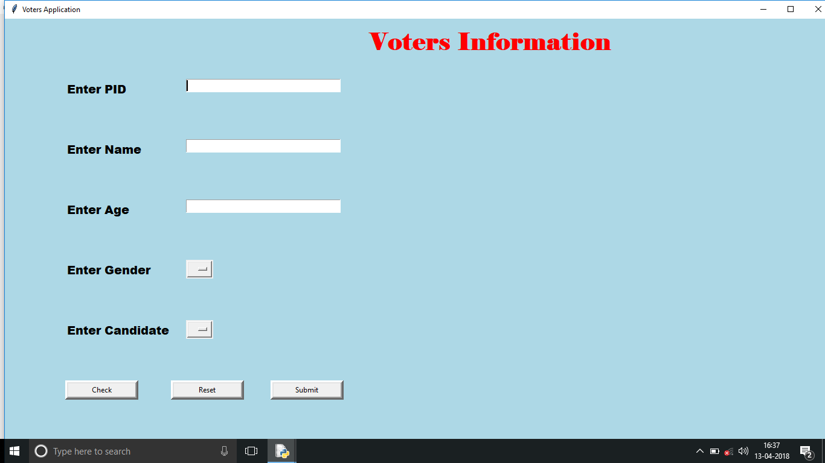

Check: 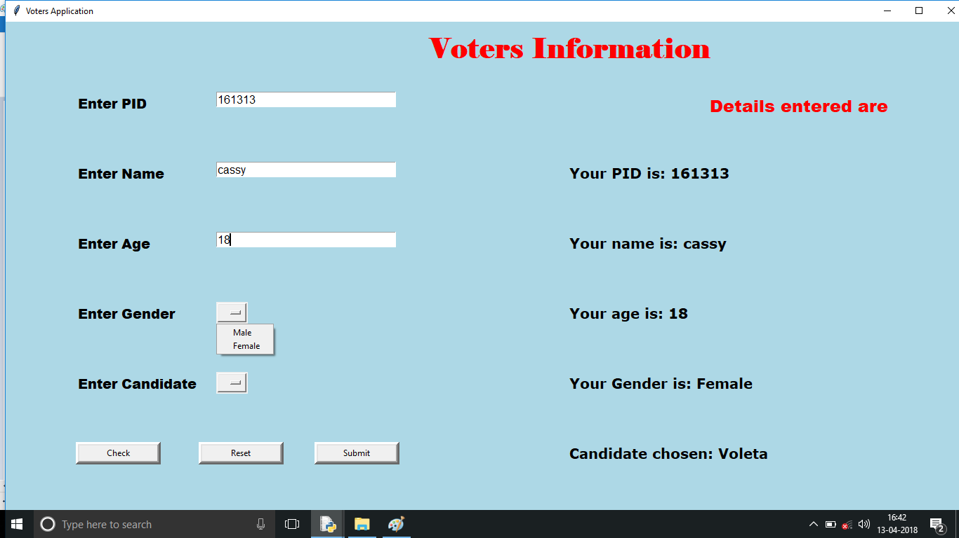

Submit:

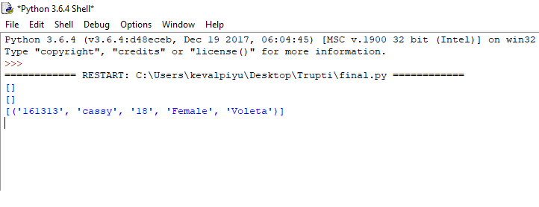

Reset:

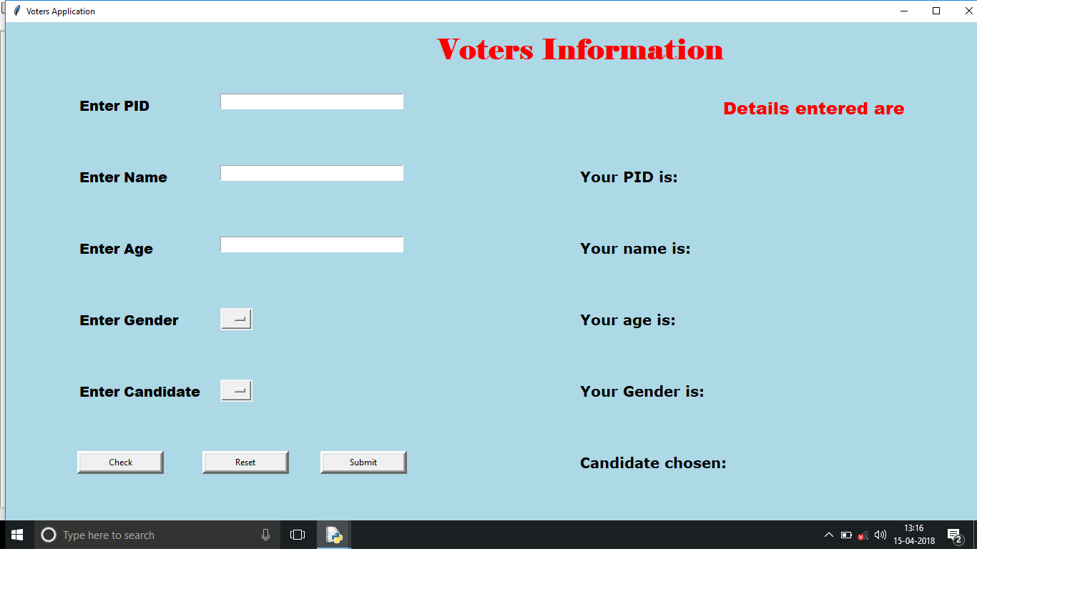

Candidate window:

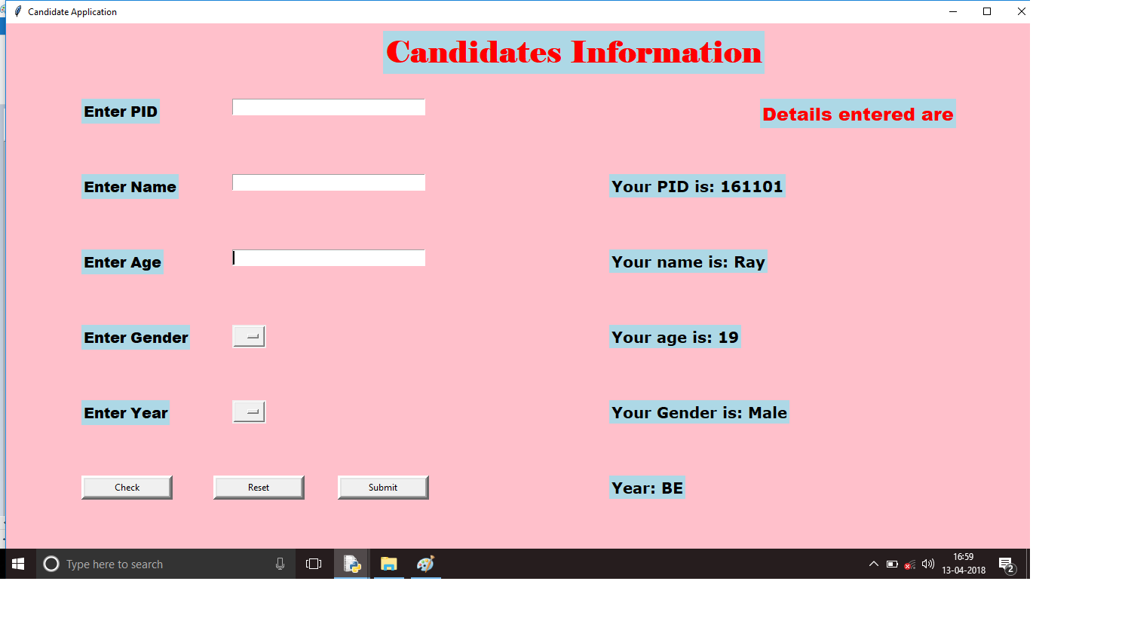

Check: 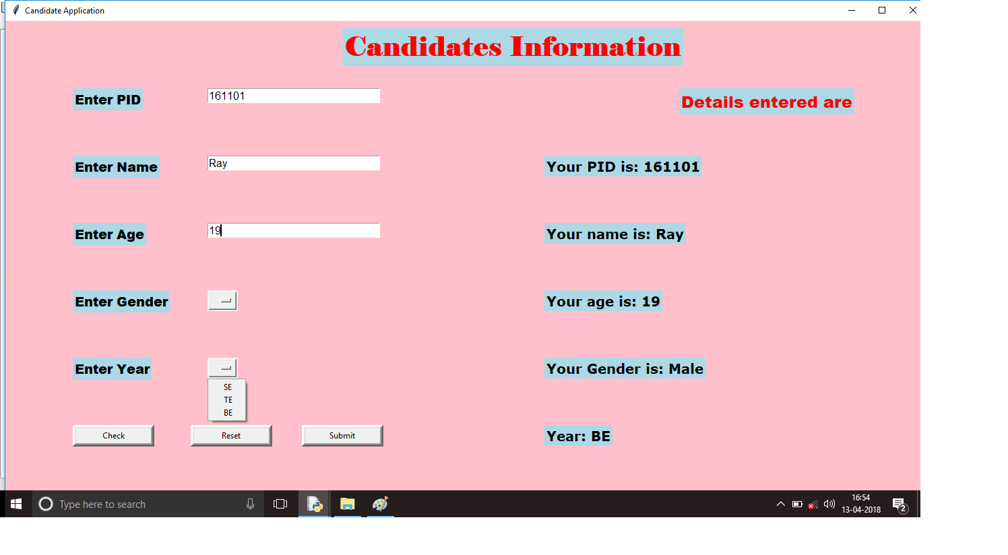

Submit:

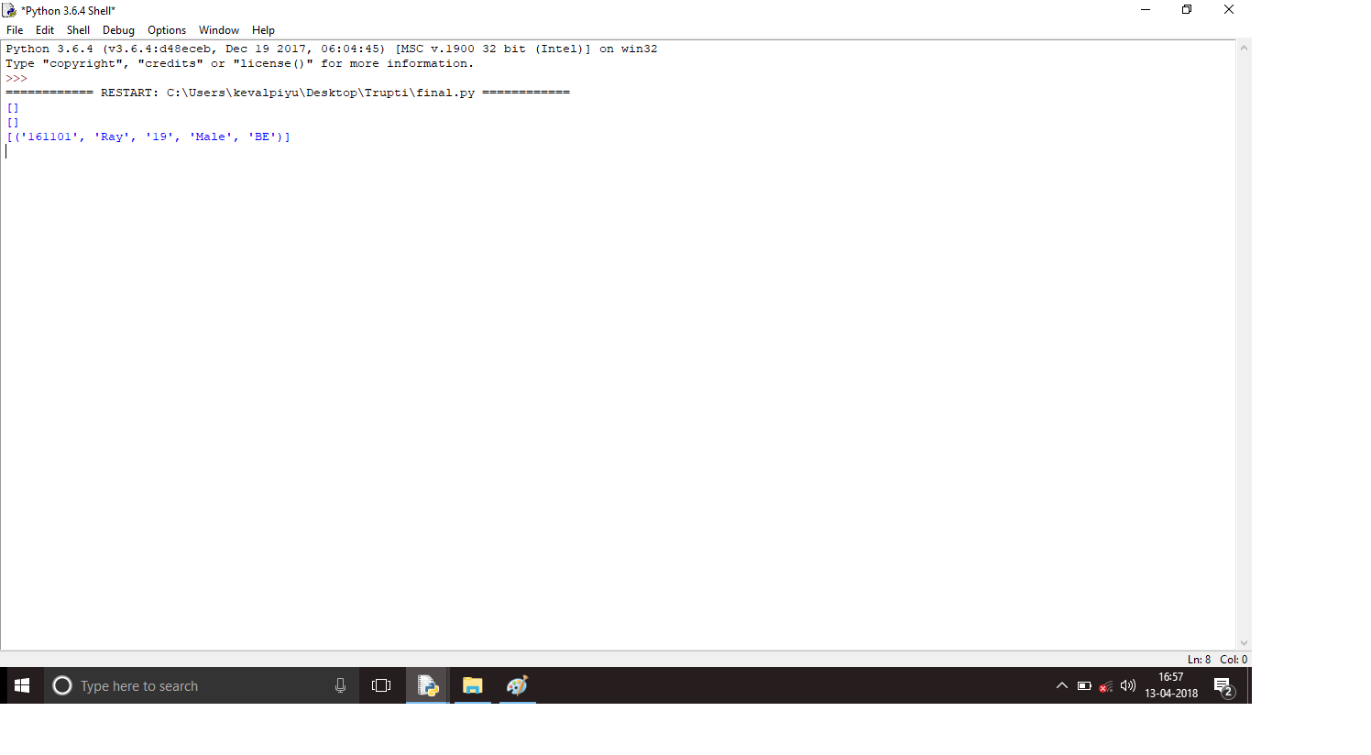

Reset: 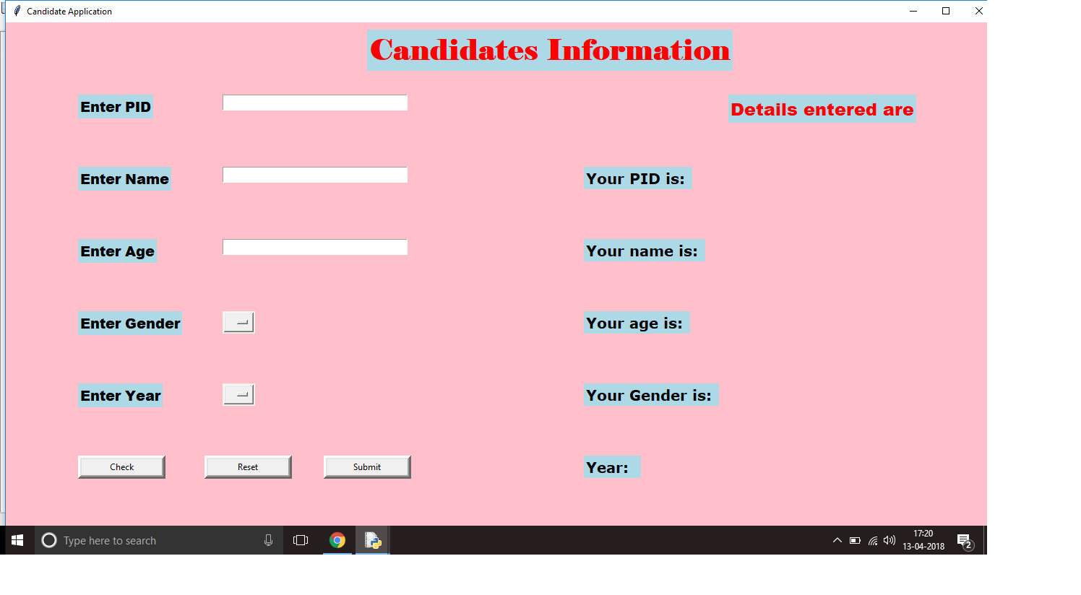

**Conclusion:** From this project, we created a GUI form to enter Voter information and their respective votes and also and new Candidates information. The use of classes, functions, widgets using tkinter and also database was used. The database used was SQLite3.Functions was linked to each button using the command attribute. Database was manipulated every time the Submit button was clicked in the forms. Reset buttons resettled the form. Check button checked the values entered so that only right values are sent to the database. This interactive form also consisted of a main window which linked to separate windows or forms. GUI using python was clearly understood and implemented. Database is created and understood through this project. Polls were managed for a college level. The project was completed and executed successfully.